Scheduled TV for ITV System
Product Design Specification
Revision: 0.1
Author(s): Hui Shao
Date Last Updated: 2004-7-22


124 Acton Street, Maynard, Massachusetts 01754
Phone: 978-897-0100
Fax: 978-897-5065

Revision History
Revision | Date | Who | Description
0.1 | 2004-7-27 | Hui Shao | Initial draft
02 | 2004-9-23 | Jianjun.Wen | Internal discussion

Table of Contents

Contents
Revision History ii
Table of Contents iii
Contents iii
Purpose 5
Overview 6
Related Documentation 7
Design Status 7
Constraints 8
Assumptions 8
TBD 8
Prototype Status 8
Operations overview 9
Operations scenarios/scripts 9
System performance considerations 9
Detailed Design Specifications 9
Functional Hierarchy 10
Data Flow Description 10
General Conventions 10
Design Description(s) 12
Data Structures 12
Input 12
Process 13
Output 16
Error Codes 16
Data Interfaces 18
References 20

Purpose
The product design specification (PDS) has the following functions:
- Provides a detailed description of capabilities and external characteristics of the product.
- When appropriate, describes the relationship of this product to other products using block and flow diagrams.
- Describes all aspects of user interface including input, expected output and error conditions.
- Identifies components that may be candidates for re-use in other products or components of other products that may be used in this product.
- Identifies other related documentation, i.e. product plan, requirements document, design specification and test plans.

Overview
Provide an overview of the product and describe the features that will be implemented. The following topics should be covered.
- Is the product a Windows Application, service, DLL or a combination of all of the above?
- Describe the overall application. If the product is a Windows Application describe layout of the main window.
- Provide functional block diagram and program data flow when appropriate.
- Design drivers and their order of importance.
- Re-use strategy.

The Scheduled TV system is intended to deliver uninterrupted linear scheduled streams in ITV VOD configurations. Delivery of content is consider “output only” in that it is derived from a customer supplied schedule detailing exactly what assets are to be played, when the assets will air, and what specific services the asset will stream over. Scheduled services are autonomous in that they will stream assets in the sequence defined by the schedule without regard to how many end users may be tuned in to the service. End user consumers will have the ability to tune in or join a scheduled service based on external conditional access but will have no ability to request specific content, manipulate the service via set top controls, or otherwise influence the delivery of the content being streamed over the service.

Scheduled TV extends and enhances the ITV platform by delivering the capabilities and functions most commonly found in Near Video On Demand (NVOD) systems. Schedule TV will enable the ITV platform to deliver scheduled content on a pay per view event basis, stagger cast broadcasting, repetitive event scheduling, per day event scheduling, randomized and serial barker or carousel channels, and load balanced feature scheduling.

Scheduled TV is also an enhancement of the current SeaChange VOD Barker system. SeaChange VOD Barker system employs the robust and feature-rich VOD Command Center components to deliver barker channel services. Hence, the operator uses familiar tools to deliver the barker channels. These sophisticated management tools enable the operator to operate their systems from near or afar. The existing SeaChange Barker Channel product has three major limitations that are impeding the wide spread acceptance of this product within the SeaChange VOD installed base (as well as the ability to sell it to non-SeaChange VOD customers). These limitations are expected to be removed in the Scheduled TV Barker Channel. Specifically, they are:
  - The RunBG utility is used to generate the barker channel stream from the SeaChange VOD system. If the VOD Barker server or the RunBG application terminates then the stream will discontinue until the operator restarts the RunBG program. In other words, there is no automatic restarting of the stream if the initiator (RunBG) terminates.
  - The operator must edit the RunBG input.txt file to create the list of what assets are played out of which barker outputs.
  - Content is played back-to-back without any concern for the integrity of the MPEG stream; i.e. there is no splicing. Hence, the content must be encoded to fade to black at the end in order to ensure proper back-to-back playing of the barker channel content.

The following components will be included in the Scheduled TV implementation for ITV system:
  - SITV (Scheduled ITV or Scheduled TV for ITV)
An ITV application service that enhances standard ITV system by adding the capabilities in NVOD and Barker system
  - SITVPlugin (AM plugin for Scheduled TV)
An ITV asset manager plugin DLL that defines STV specified meta data and property pages
The SITV and SITV cover the interactions with the standard ITV system. They also work with SM (schedule management), a schedule/playlist management user interface, to response schedule or playlist administration.

Related Documentation
Provide a list of related documentation and locations where they can be found. The list should include product plans, requirements, functional specifications, test plans, etc.

- Product Requirements for Scheduled TV as Part of the SeaChange Barker System, Rev 0.2, Steve Davi
- Scheduled TV Features Description(DRAFT), Deb Dalton, Anwa Huang, Dan Powell
- SeaChange ITV Scheduled TV, ZQ draft
- SeaChange VOD Barker System Version 1.6 SPD Revision 1.2
- SM Interface with Ingest and Playback, 1.0.4, Hancel.Shao
- SeaChange Interactive Television Real Time Streaming Protocol Client Interface Specification (DRAFT) Revision 1.5.0, Nancy Wimberg, Gregory Holbrow, Jim Baratz

Design Status

Constraints
List of constraints, concerns and problem areas and their affect on the design.
The SITV program must run as a Windows service using the SeaChange Service Shell and App Shell, and be able to run on Windows2000 or Windows 2003. The program must be configurable through the ITV Configurator service, and must support ManUtil interface and SNMP.
SITV must provide all the functionality currently available in the SeaChange Barker Channel product. Specifically, it must work in all four environments; i.e. Open ITV, Motorola, SA with ISA and SA without ISA
SITV must allow import of content without all of the normally required metadata, which can probably achieved by creating a new Asset Manager plug-in, SITVPlugin).
SITV must work with SM, the user interface of schedule/playlist management, for ease of operator control for definition of assets that are part of each streaming. The interactions was defined in SM Interface with Ingest and Playback
SITV must provide for smooth transitions between assets and limit the number of non-smooth transitions to a very small number. Specifically, it MUST use the smooth splicing capabilities of VOD v2.0.
SITV must process as many simultaneous channel requests at once as possible (at least 20).

Assumptions
List of assumptions and possible effect on the design if they are wrong.
If SITV shutdown, SITV would comeback at the restart time.
If SITV break connect,SITV would comeback at the connect time.

TBD
List of TBD requirements and an assessment of the effect on system size, required effort, cost and schedule.
The first version not control on line.

Prototype Status
Describe current level of prototyping done to prove out concepts to this point.

Operations overview

Operations scenarios/scripts

System performance considerations

Reliability
As a service, SITV inherits all the reliability from a standard SeaChange VOD service. All threads used in the program will be pooled by invoking SeaChange’s ScThreadPool.dll. SITV provide dual rail network support when communicating with other VOD Command Center components, and provide an effective app-shell keep-alive test
Compatibility
As a standard SeaChange service, the new service will has interfaces to ManUtil, alarm, pager and other standard SeaChange utilities. Besides them, the new service will not require additional ITV components to work, in other words, it has minimal dependents to run.
The new service can work on the existing ITV deployment without requiring additional hardware.

Detailed Design Specifications

Functional Hierarchy
Describe where this product fits in with other products and how it may be used. This is actually a textual description of the Functional Block Diagram.

SITV works as an additional ITV application service. It invokes ITV ISSAPI to provide dynamic playlist and limit the non-smooth transactions between assets, and it sinks the streaming events from MCA, SRM, CM.
SM interface and local schedule management subsystem of SITV exchanges schedule or playlist data and the play status with SM(Schedule Management), which provide an easy-to-use web-based user interface.
SITV also has its internal RTSP client module to start a stream on ITV based on the time points of the active schedules. It can manages multiple schedule sessions
SITVPlugin is an ITV asset manage plugin. It is to be attached in the AM to manage the Scheduled TV –related meta data definition. SITVPlugin also provides property pages for users to input the customized meta data

Data Flow Description
Describe data flow between this product and other products in the system.
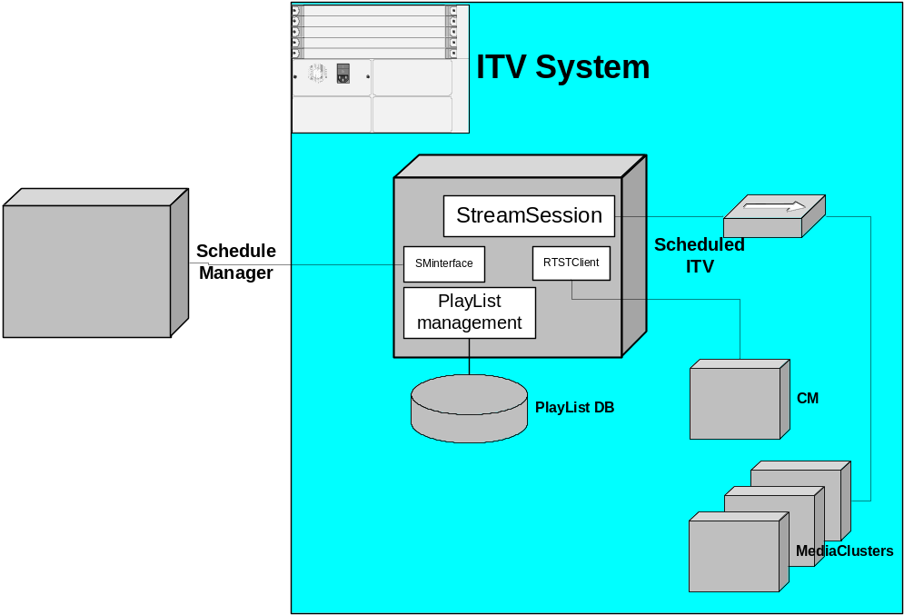
Figure 4.1 SITV deployment and components

SITV is a SeaChange application service that will be installed in one or two of the ITV command center cluster. It also can be installed separately in an additional box with the command center LAN.
The following describes the data flow briefly:
- SM sends playlist to the SITV thru the SMInteface
- The playlist managemet creates playlist to associate the new playlist and maintain the data with the external DB
- When a channel start timepoint is met, the service kick off a stream by sending RTSP requests to the ITV CM via the RTSPClient module
- A new StreamSession is created to response the ISSAPI newstream callback
- The StreamSession associate the related playlist and apply the asset scheduled in the playlist to that ITV stream by invoking ISSAPIs
- The StreamSession also monitors the status change of the ongoing stream

General Conventions
This section describes the naming conventions or special notations that may be used in the detailed functional descriptions.

Term | Description
SITV | The scheduled ITV applicaton service name, also it is the main service class name, SITV.exe will be the targe service image filename
SITV service | See SITV
SM or Schedule Manager | This is Play List contoel and manage.
Channel | The channel in this document is a combination of an IP address and a port number that a stream pumped on. The IP address can be unicast, multicast or broadcast address. For example, 225.12.12.12:1000
Stream | Play Media stream
StreamSession | Play Media stream session information
Timepoint | Stand for a timer thread dealing with time points.
Playlist | Stand for a playlist passed through SM Interface.
RTSP | Real time stream protocol

Scheduled ITV Application Service Description
Design description for each subsystem or function. Include capabilities, assumptions and restrictions and high level description of input and output. This section should be copied and filled in for each major component or function of the product.

Program Structures
Structure charts or object-oriented diagrams expanded to the subprogram level, showing interfaces, data flow, interactive control, interactive input and output, and hardcopy output.
Internal storage requirements, i.e., description of arrays, their size, their data capacity in all processing modes, and implied limitations of processing.

Input
Provide a detailed description of valid user or program inputs for this function. If there is a range of acceptable values, list the minimum and maximum values. In the case of an application interface, include keyboard accelerators, menu values and dialog boxes.

Service Configuration
TBD

SM command messages
They are received from SMInterface. See SM Interface with Ingest and Playback for more detail.
The message can be divided into 2 parts: Message header and body:
        - Socket message format:
Message | Description | Data length
Version | Protocol version | 1 Byte
Length | Message length (BYTES) | 1 Byte
Message | Message body | Maximum4GB
        - Message body is XML-based. SITV supports the following SM command messages:
Action Code | Description | System
1001 | Send Schedule List | ITV and Broadcast
1011 | Play Specific asset | ITV and Broadcast
1012 | Skip to Specific Asset | ITV and Broadcast
1013 | Hold Next Asset | ITV and Broadcast
1014 | PLAYBACK Enquires Schedule | ITV and Broadcast
1015 | Play Filler Immediately | ITV and Broadcast
1021 | Status Feedback | ITV and Broadcast
1022 | SM Enquiry the Status | ITV and Broadcast
1031 | Send PlayList to BARKER System | ITV
1041 | Send FillerList to Playback | ITV and Broadcast
1042 | Query FillerList | ITV and Broadcast
1051 | SM sends configuration | ITV and Broadcast
1052 | Configuration Enquiry | ITV and Broadcast
1058 | Startup a Channel | ITV and Broadcast
1059 | Shutdown a Channel | ITV and Broadcast

Timepoint Events
This is an internal timer –base event. It will be re-set to the nearest timepoint [re-fresh] whenever it processed a timepoint event.

Stream Events
This type of events is fired from the ISSAPI callbacks. The program of SITV mostly focus on:
- OnNewStream()
- OnStreamStatusChanged()

Stream Operation Events
This type of events is fired when ITV stream server received a stream option request (e.g. RTSP request) from end-user. In SITV, those events should be ignored when a stream is ongoing

RTSP response and announce
When the service send a RTSP request out, it expect to receive a RTSP response from the stream server
The stream server also periodly send RTSP announces back based on the stream status

Process
Provide a detailed description of how this function should work.

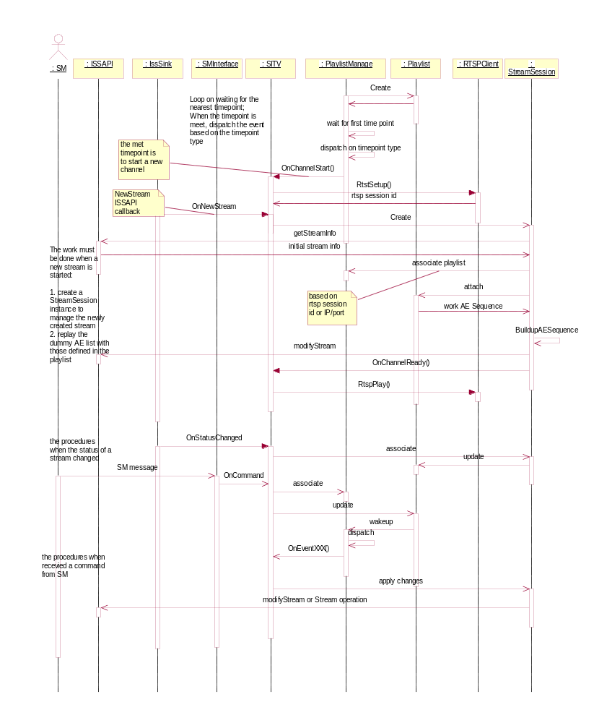

PlaylistManager Control Loop
Sleep and in-playlist timepoints
- PlaylistManager is waiting for timepoint event
- Once a timepoint event is met, it dispatch the excution routine based on the timepoint types, and
- It also re-scans the playlists to determine the nearest timepoint to sleep
- Sleep till the newly calculated timepoint

Playlist Modification
- Any playlist modification by the service or SM command will fire a timepoint event to wake up the PlaylistManage Control loop to re-fresh the nearest timepoint

SM command process
- The SMInterface received a command message from SM, parse it
- The Service SITV process the command
- Associate to an active playlist instance if the command is playlist-oriented
- Apply the updates to the playlist
- Wake up the playlistManager control loop and refresh the nearest timepoint

Launch a Channel
This is a timepoint-event process
- The playListManager waked up on a start-a-channel timepoint and fire OnChannelStart() event call to the service
- SITV calls RTSPClient to send RTSP SETUP request
- The RTSPClient response with a newly created RTSP session ID, keep the RTSP session ID in the playlist instance
- ISSAPI fires a OnNewStream() event call from its callbacks
- SITV create a new StreamSession to bind this stream
- The StreamSession get some initial details about the stream
- The StreamSession associate the related playlist instance managed by the PlaylistManager with the information of IP+port or RTSP session ID
- The StreamSession attach itself to the playlist with bi-direct links
- The StreamSession build up the real AE list to play based on the playlist setting
- The StreamSession calls ISSAPI to apply the playlist-defined AE list to the stream
- The StreamSession fires a OnChannelReady() event call to the service
- The service calls RTSPClient to send a RTSP PLAY request

Responses Stream Status Changes
When the stream is ongoing, SeaChange Stream Server notices the related components about it status. The program trace this changes to keep the playlist status up-to-date.
- IssSink fires a OnStatusChanged() event call from its callbacks
- The service associate the related StreamSession instance via Stream Identification
- The StreamSession instance update its own status and the related status information in its attached playlist status
- The playlist instance wakes up the PlayListManager control loop if necessary.
- Sends status change message to SM if necessary thru SMInterface

Output
Provide a detailed description of expected output from this function, including any error conditions that may occur.

Scheduled Stream
The SITV drives ITV system to pump stream out base on the scheduled playlist.

RTSP Requests
SITV also works as a RTSP client. It starts a new stream by sending a RTSP SETUP request followed by a RTSP PLAY.
The RTSP requests are term service based, and implemented in RTSPClient. Please see SeaChange Interactive Television Real Time Streaming Protocol Client Interface Specification for more details on the extended protocol.

RTSP heartbeats
When a RTSP session is established, it is required to keep sending heatbeat messages to the server to make the session alive. SITV sends blacklines as the heartbeat signals

Detailed and leveled log messages

Modules

Playlist, PlaylistManager and Playlist DB

Module Responsibility
The primary responsibility of P&PM module falls into the following categories:
- Maintaining playlists and ensuring data consistence.
- Automatically recovering after service crash restart.
- Tracing playlists start time point and bringing up streams.
- Building Asset Element (AE) list.
- Responding to SM commands and invoking corresponding playlist operations.

Static Class View
Three classes play vital roles in P&PM module; STVPlaylist, STVPlaylistManager, and STVPMTimerMan, as Figure 2.
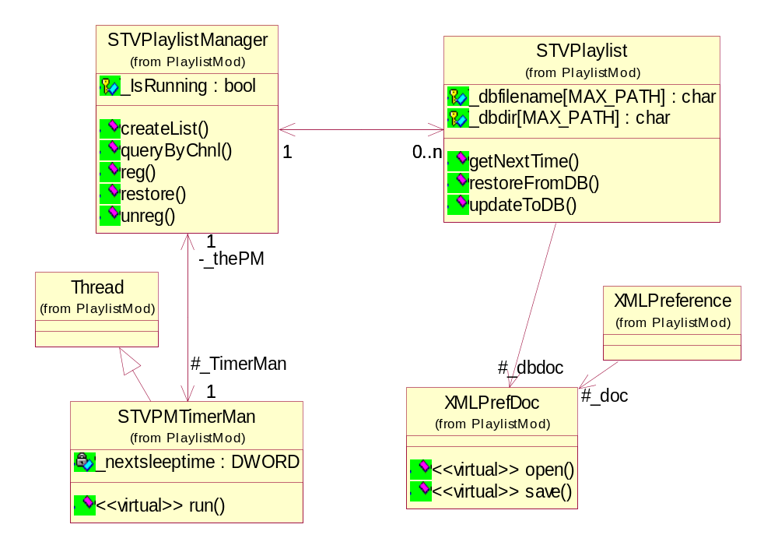
Figure 2

Workflow
STVPlaylistManger creates STVPlaylist objects according to XML stream input and does corresponding operations. Another thread class called STVPMTimerMan query next time point separately and automatically falls asleep until time point match or STVPlaylistManager modified playlist pool. STVPlaylist objects deal with database mirror issue and notify output module to setup new RTSP stream. The workflow is represented by sequence diagram as Figure 3.
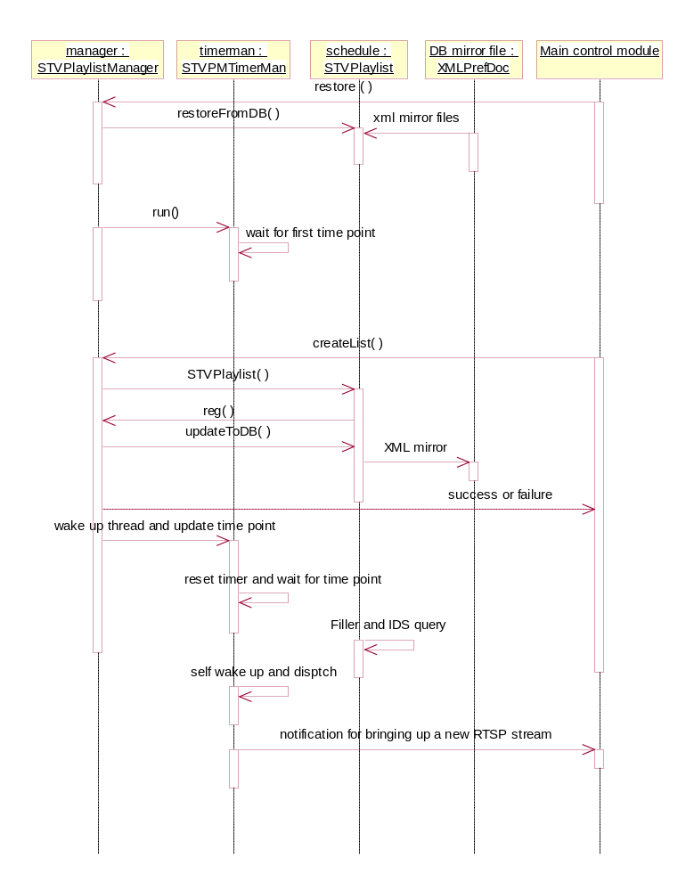
Figure 3

AutoFiller and BarkerFiller

Module Responsibility

When users design Schedules, there perhaps will be a time break between 2 schedules which is IEs defined in SM. If service acts nothing here, custom will watch a long time black screen.
To avoid this kind of problem STV shall fill the break time with some trick film such as small films, advertisements and so on.

Static Class View
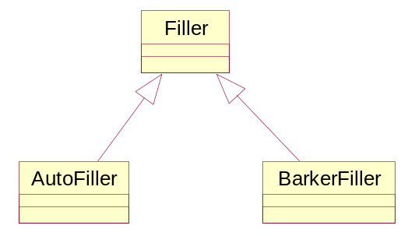

Schedule Manager Connector

Module Responsibility
interface with extern module, connecting to SM with failover, receive command, parse command, send command.

Static Class View

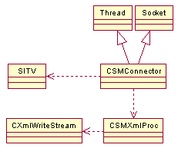

Workflow
1.new or define a instance
2.call SetParam to set params
3.call start to start work, connect the sm, begin to work
4.call close to close it
5.can call isConnected, wait, and current class refrence

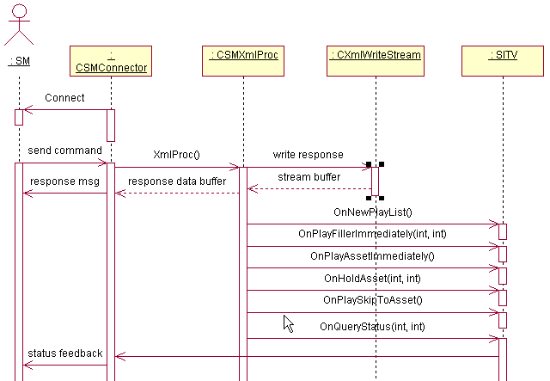

RTSP Client

Module Responsibility
The purpose of RtspClient Module is to provide Rtsp Stream control operations for STV corresponding functions. RtspClient is responsible for stream setup, play, pause, forward front, forward rear, query and terminate operations.

Static Class View
Three classes play vital roles in P&PM module; RtspConnectionManager, RtspClientConnection, and RtspMessage, as Figure 2
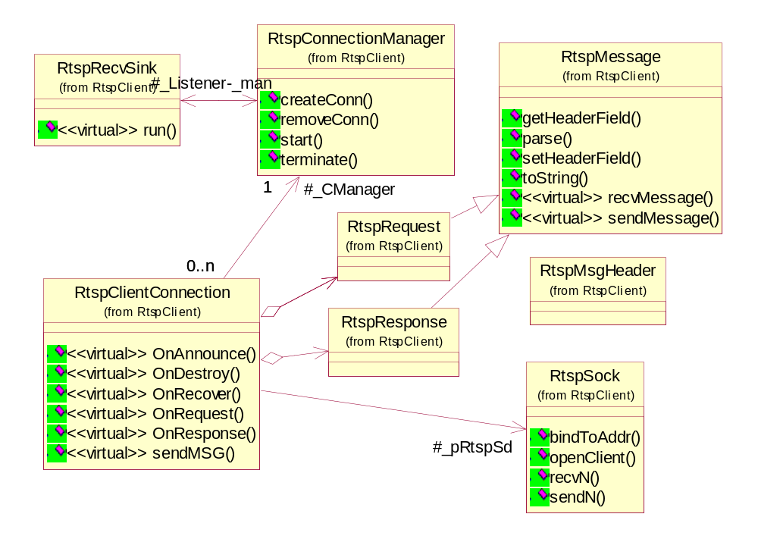
Figure 2

Workflow
- Enable to bring up and teardown stream according to asset information.
- Enable to play specific asset from specific time-point.
- Hold stream session id for future query use.
- Real time response to server.

Stream Session and Stream Sink

Module Responsibility

Static Class View

SeaChange Service Framework

Error Codes
List of numbered error messages with a description of the system and user actions
Error code | Description
1901

Scheduled ITV AM Plugin Description
Design description for each subsystem or function. Include capabilities, assumptions and restrictions and high level description of input and output. This section should be copied and filled in for each major component or function of the product.

Program Structures
Structure charts or object-oriented diagrams expanded to the subprogram level, showing interfaces, data flow, interactive control, interactive input and output, and hardcopy output.
Internal storage requirements, i.e., description of arrays, their size, their data capacity in all processing modes, and implied limitations of processing.

Input
Provide a detailed description of valid user or program inputs for this function. If there is a range of acceptable values, list the minimum and maximum values. In the case of an application interface, include keyboard accelerators, menu values and dialog boxes.

Process
Provide a detailed description of how this function should work.

Output
Provide a detailed description of expected output from this function, including any error conditions that may occur.

Error Codes
List of numbered error messages with a description of the system and user actions

Data Interfaces

References
List of reference documents.

